CHARGEABLE –QUOTE PROCESS to Call assignment to Service coordinator

L1 do the login

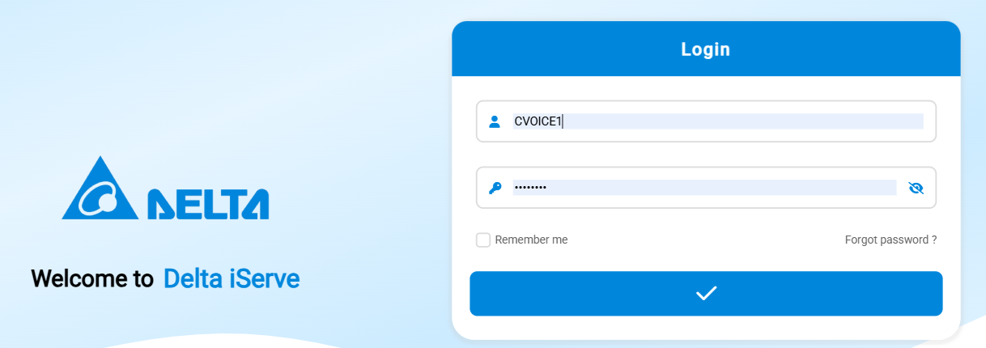

Go to service job management and log the complaint, Machine status is out of warranty

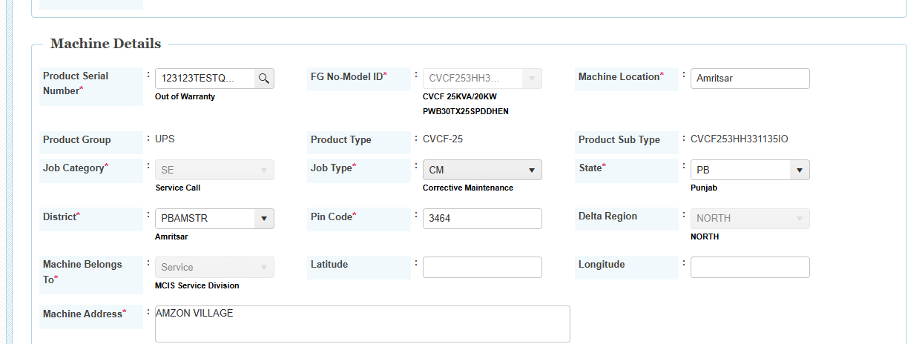

Call generated successfully

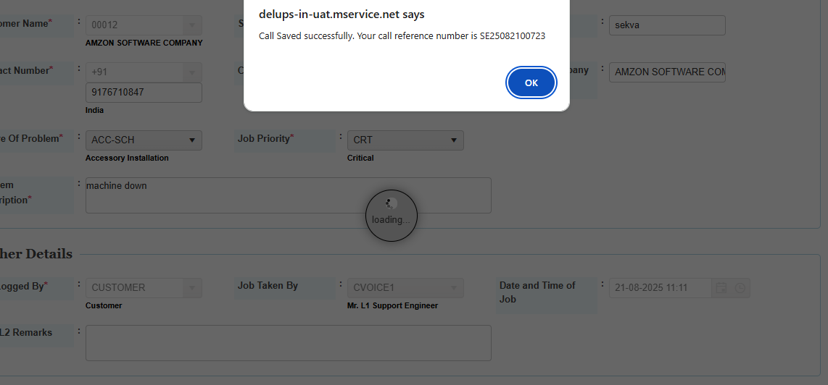

Assigned to on site support done by l1,system is showing regional sales lead as per the mapping

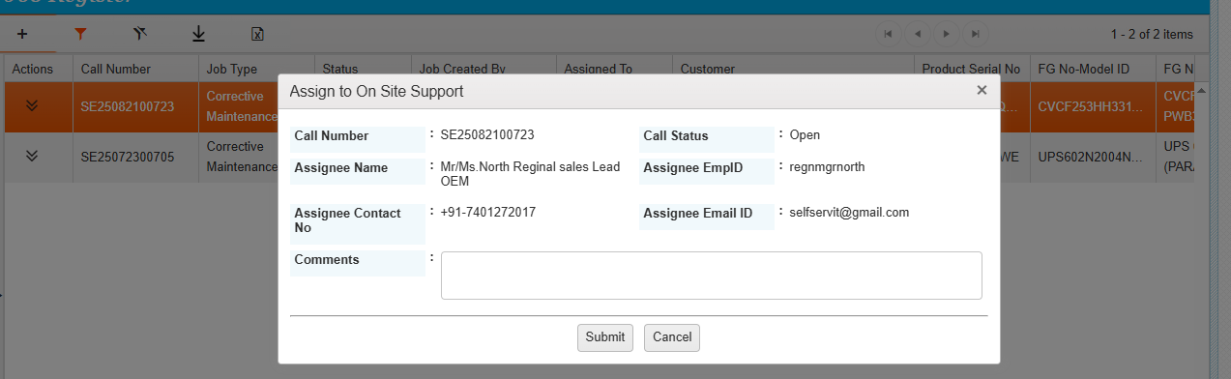

Assigned to onsite support done successfully.

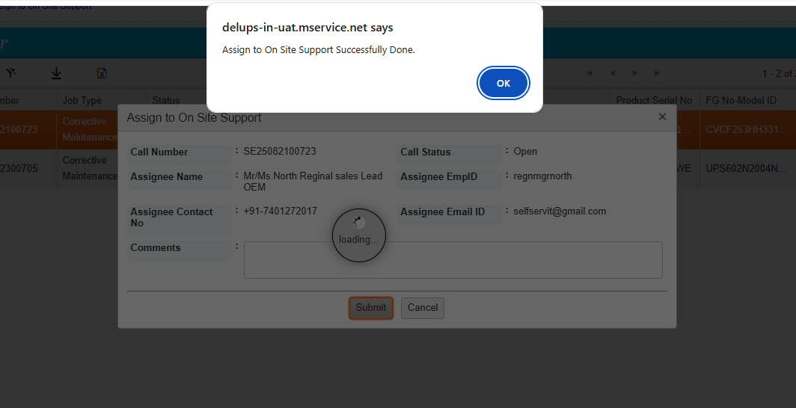

Service call assigned to sales lead.

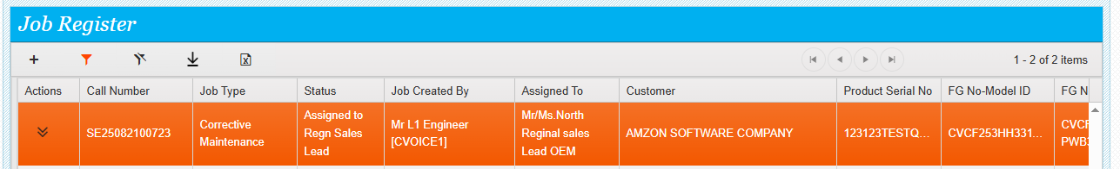

Regional sales lead do the login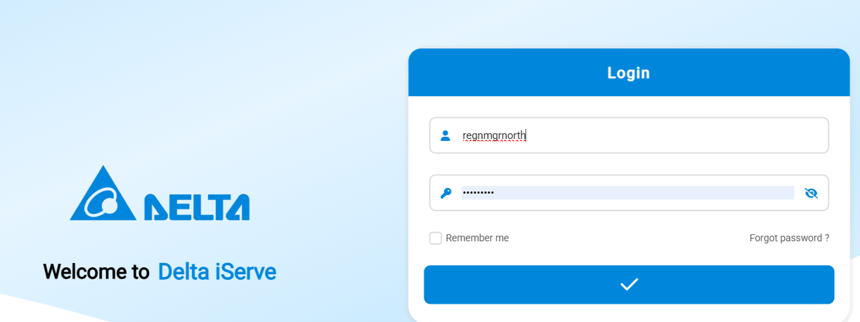

Go to service call management and see the assigned service call

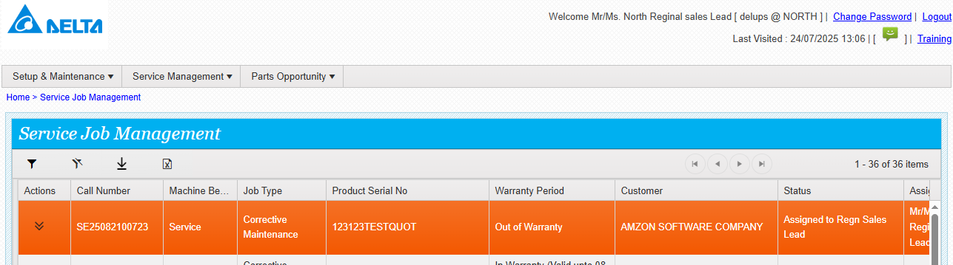click on actions and see the actions available

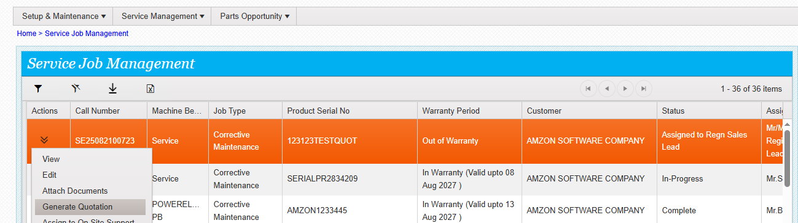

Click on Quote generation then the below screen will appear

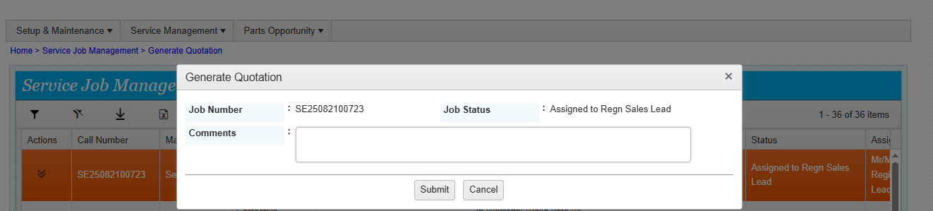

Enter the comments and click submit , then the quotation generated successfully, the link will be available to do the further quote process.

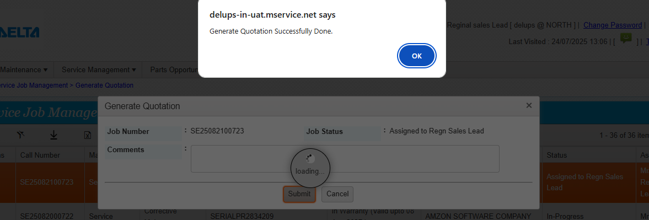

See the link for the quote

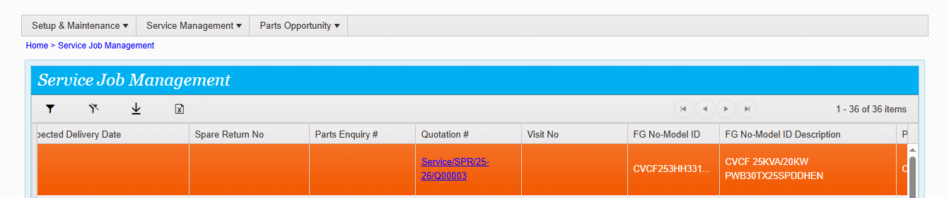

When you click on the link it will take to the quote module . the quote status is now in open draft

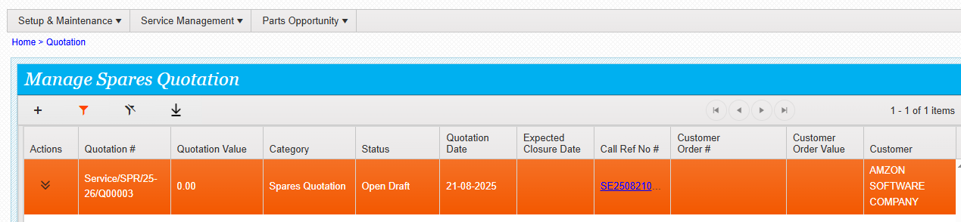

Click on action and see the actions available

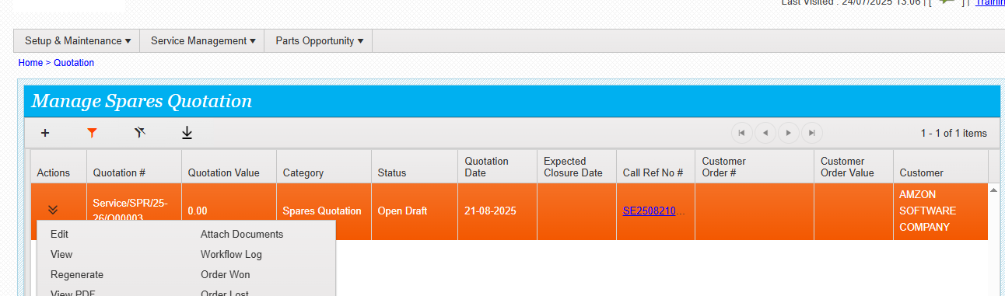

Click on edit and fill the required details.

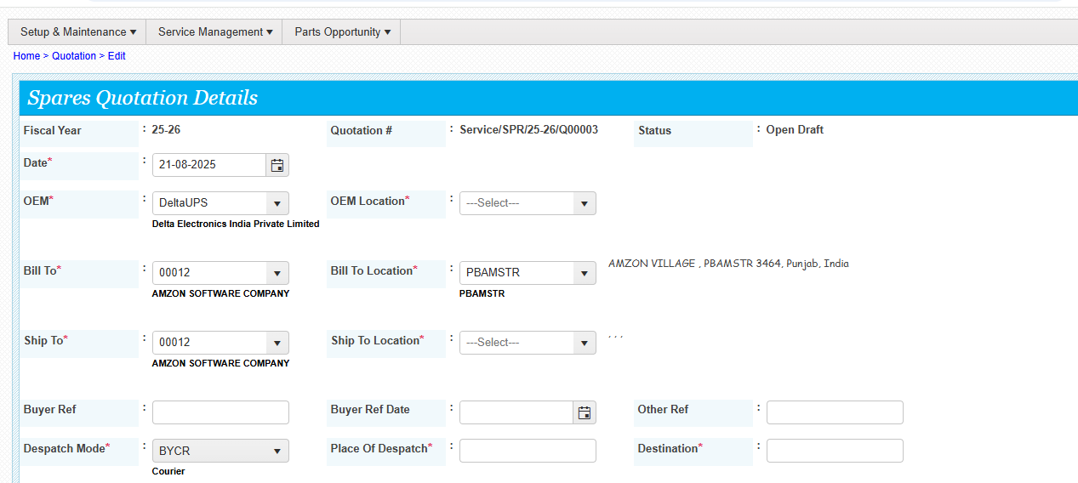

Add the parts by clicking the add button

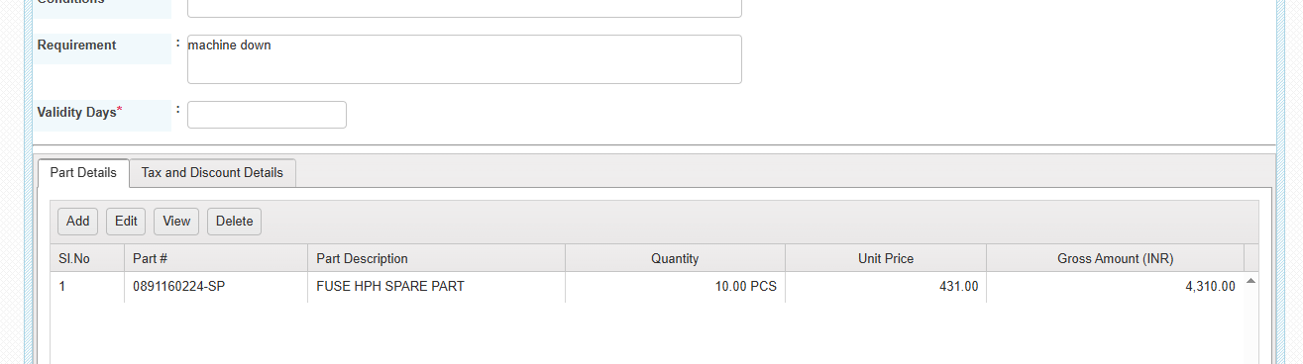

Once it is submitted then system will save the details , 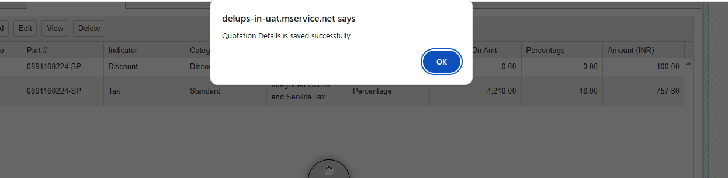

Now the status of the quote is open

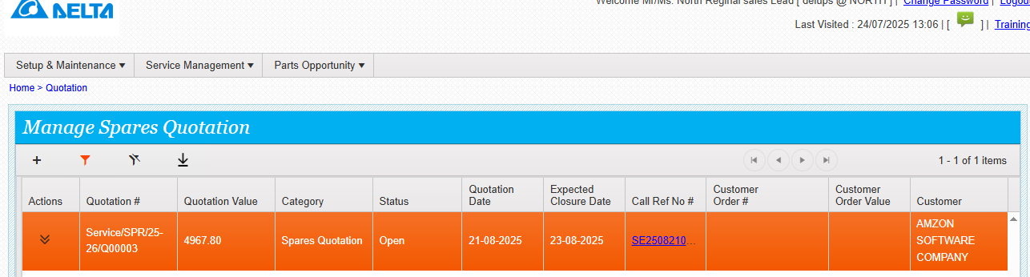

**Go to actions and click on submit for review**

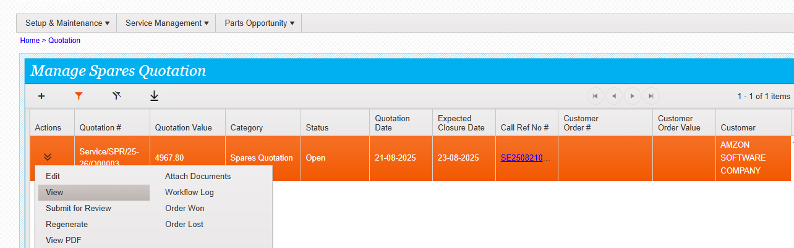

**Enter the comments and submit**

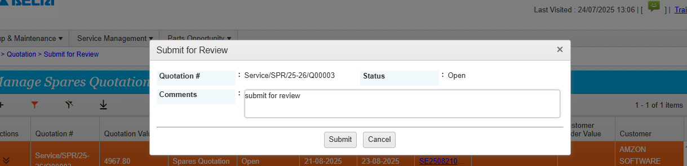

**Review done successfully.**

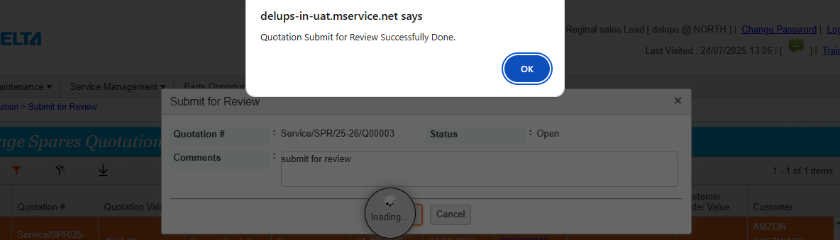

**Now the status is review**

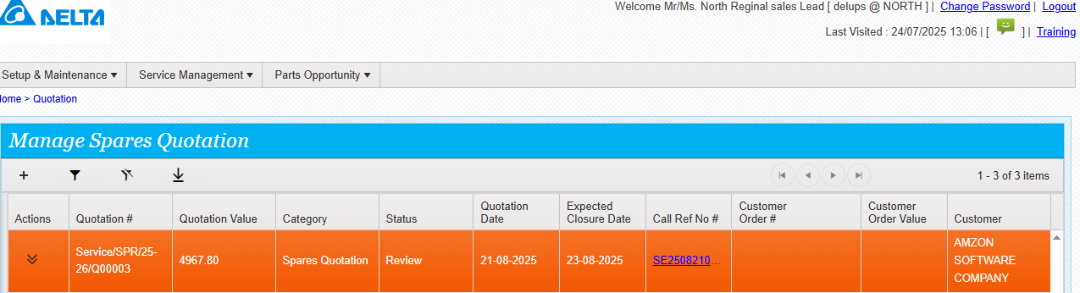

**Click on approve**

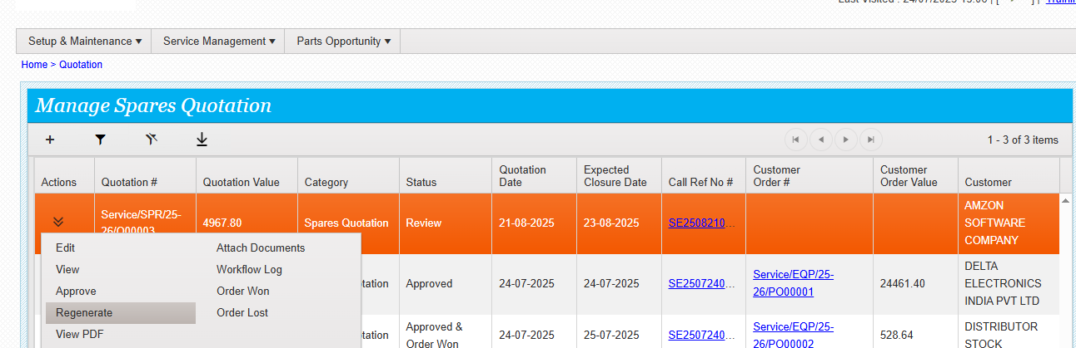

**The below screen will appear enter the comments and submit**

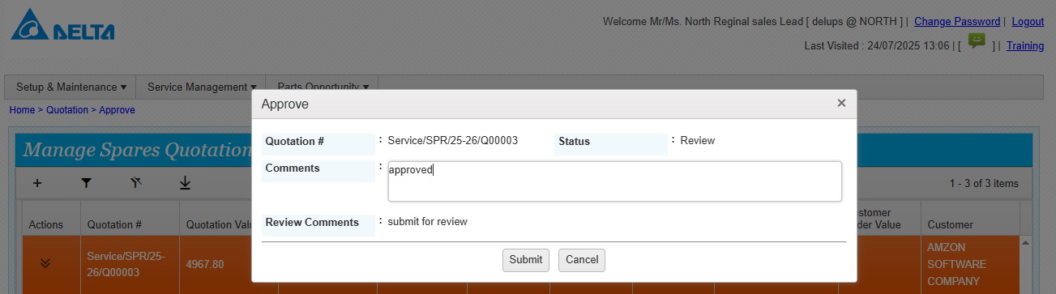

**Quotation approved successfully**

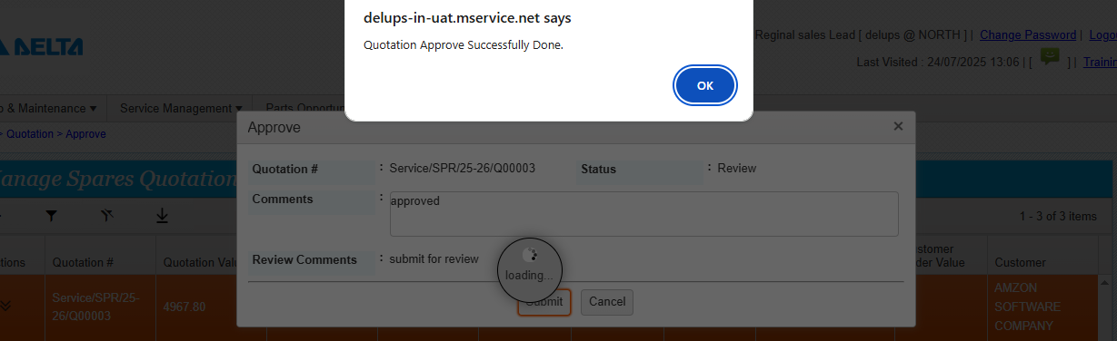

**Now the status of the quote is approved**

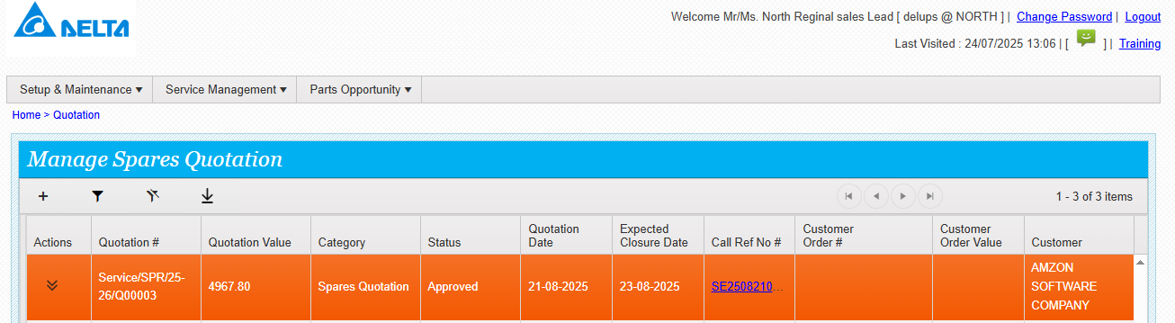

**By clicking the view pdf , quote can be downloaded and sent to customer**

**Regenerate is possible here .**

**Once the customer provide the order then customer order won can be done**

**IF order won clicked then the below screen will appear**

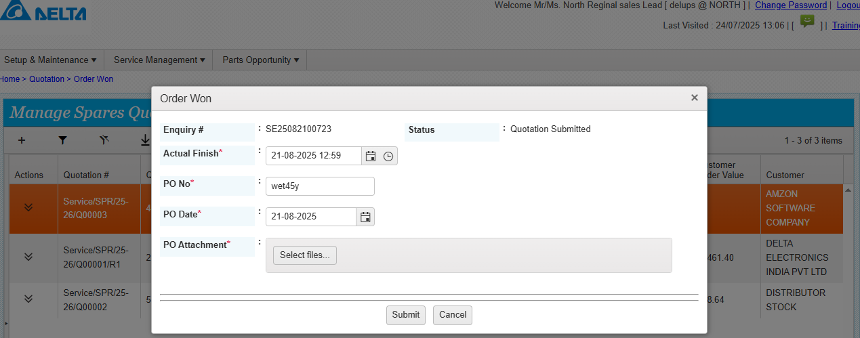

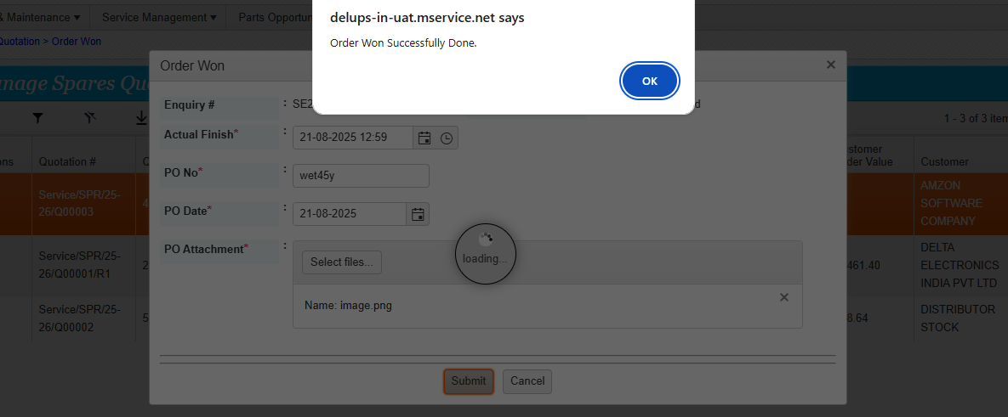

**Now the status is approved and order won**

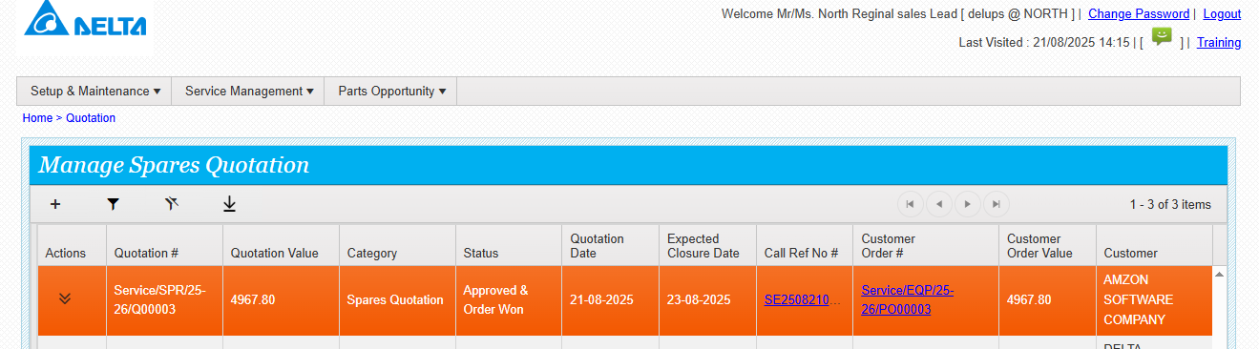

**Customer order generated**

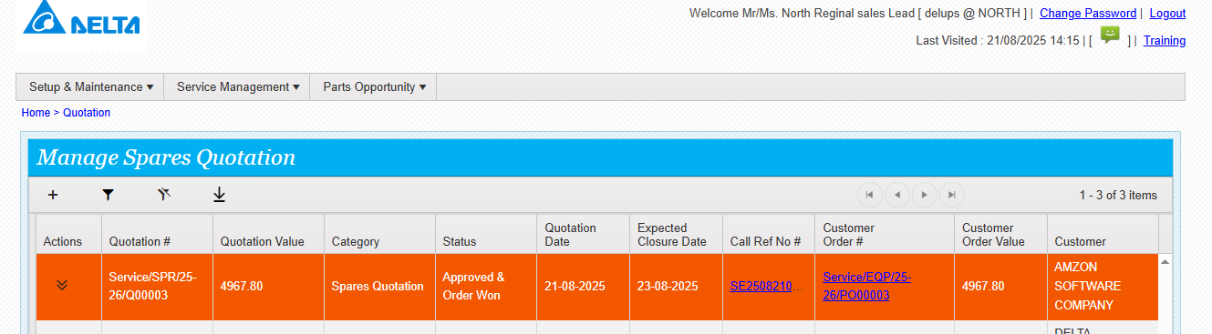

**Order status is open draft**

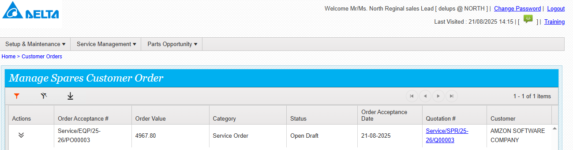

**Click on action and click edit**

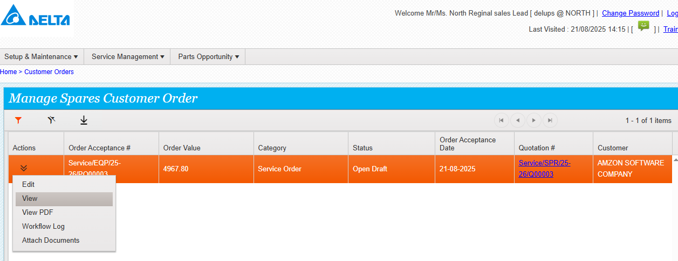

**Click edit and edit the customer order if required**

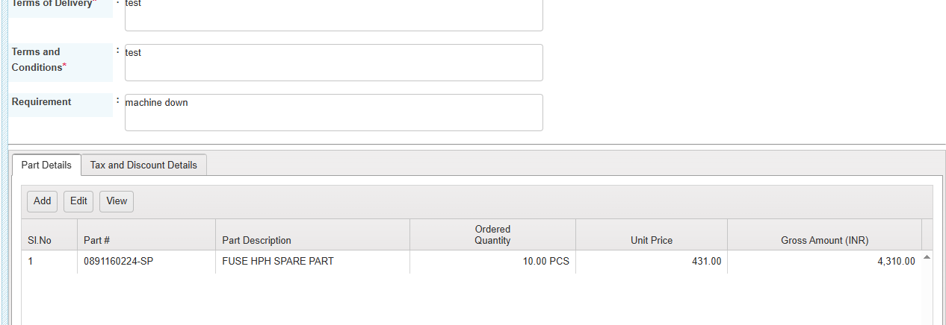

**Customer order saved successfully**

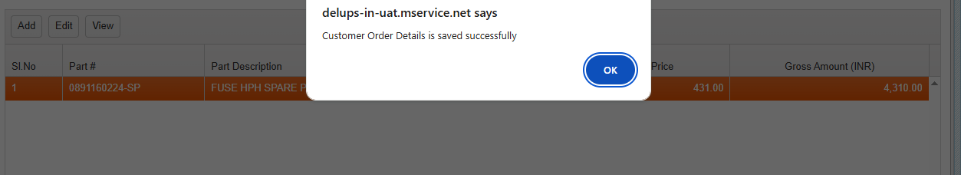

**Now the status is open**

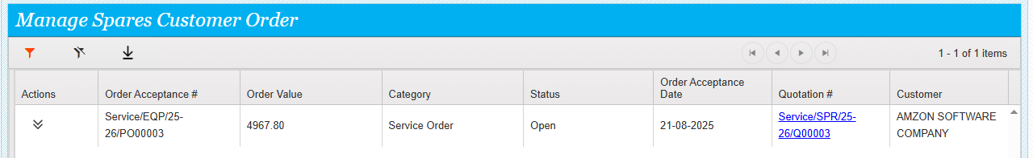

**Go to actions and click on submit for review**

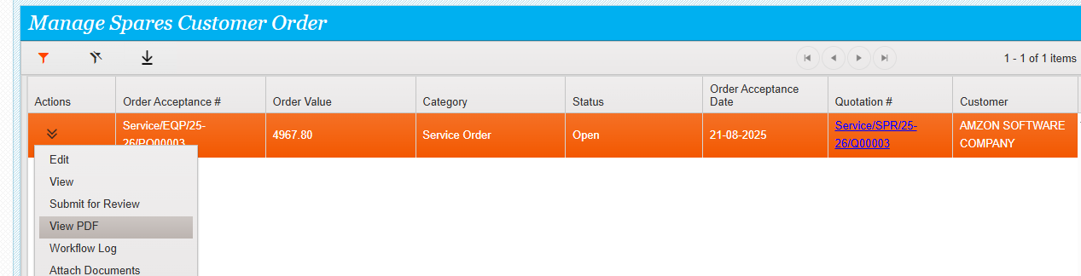

**Enter the comments and submit**

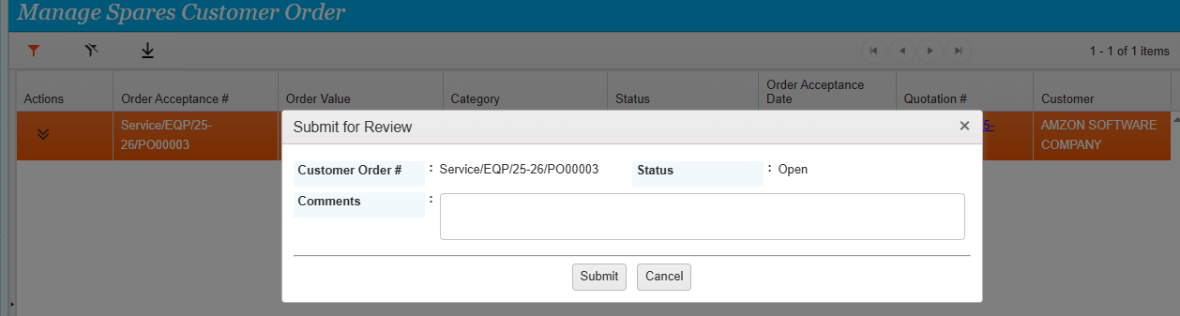

**Customer order review done**

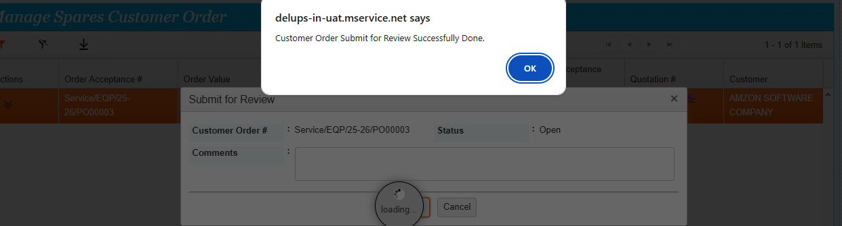

**Go to actions and click on approve**

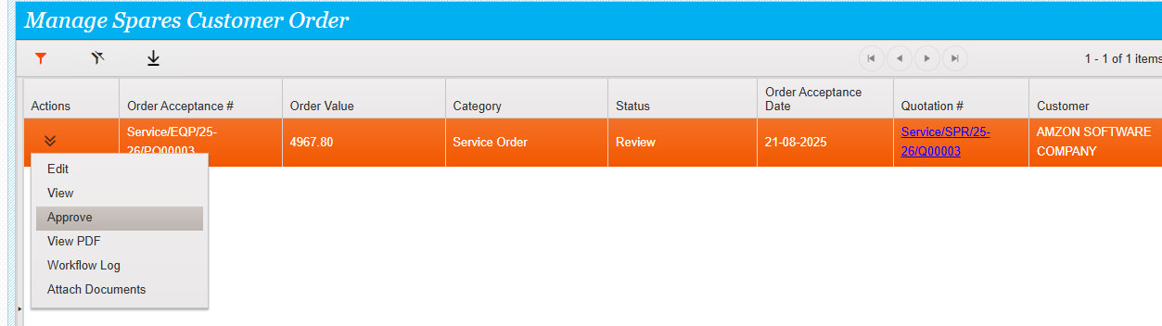

**The below screen will appear .enter the comments and submit**

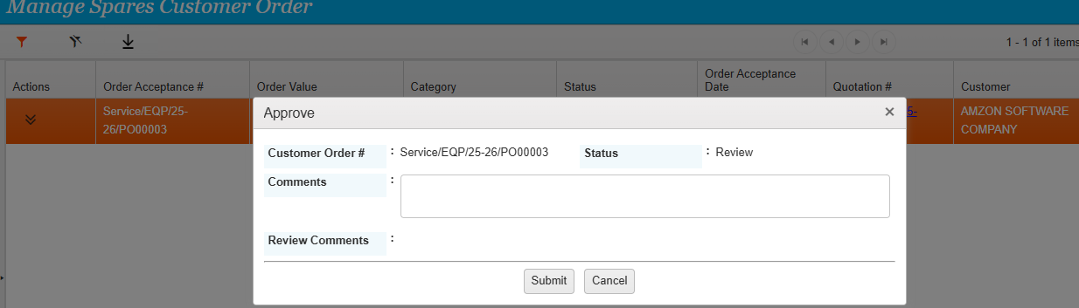

**Approved done**

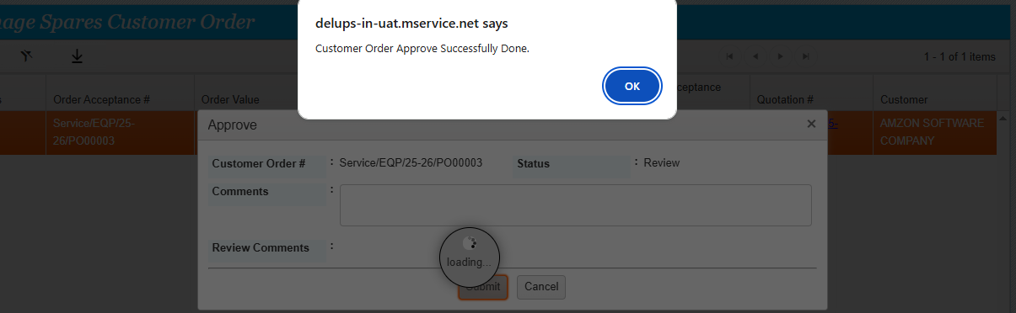

**Now the status is approved**

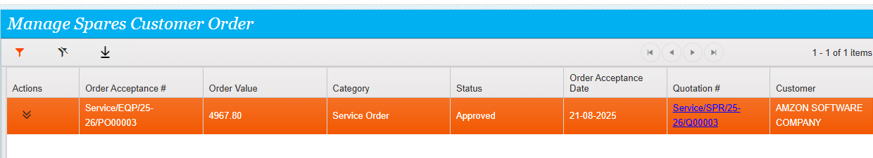

**Go to service call and see the actions available**

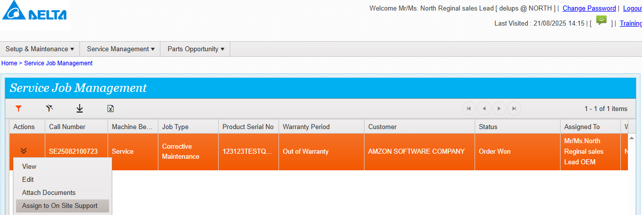

**System will show the below screen ,**

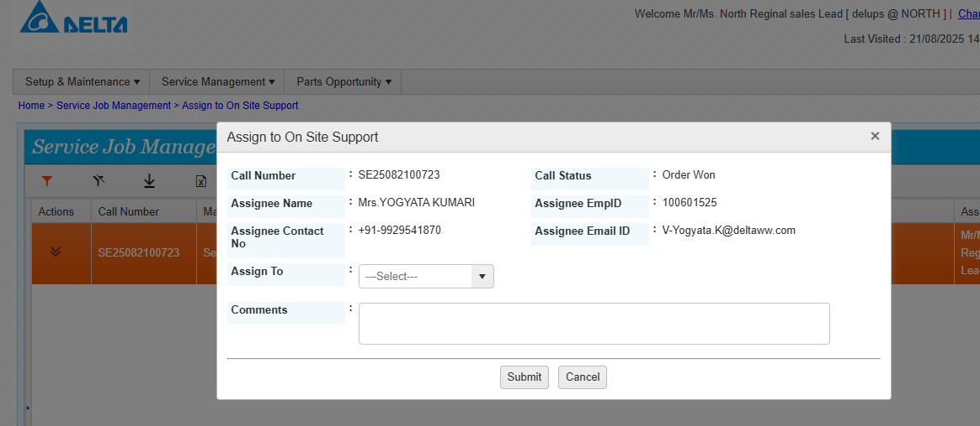

**Assigned done successfully.**

